# CS 255 System Design Document Template

## UML Diagrams

### UML Use Case Diagram

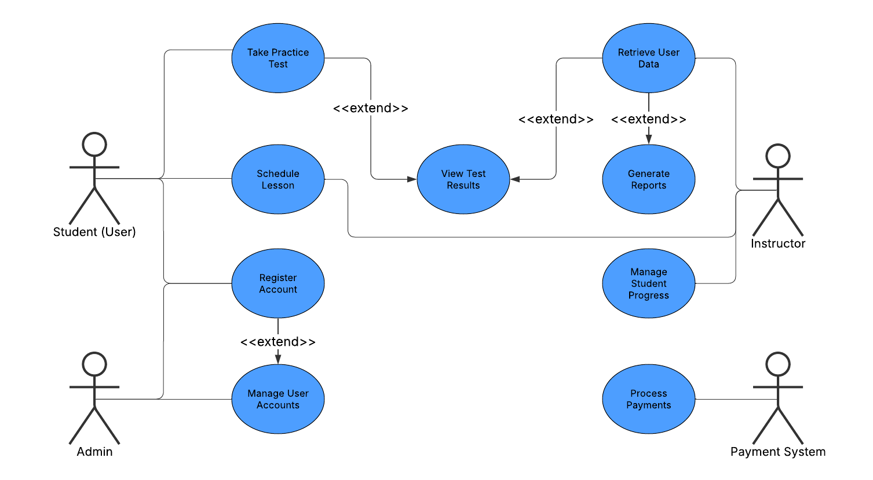

### UML Activity Diagrams

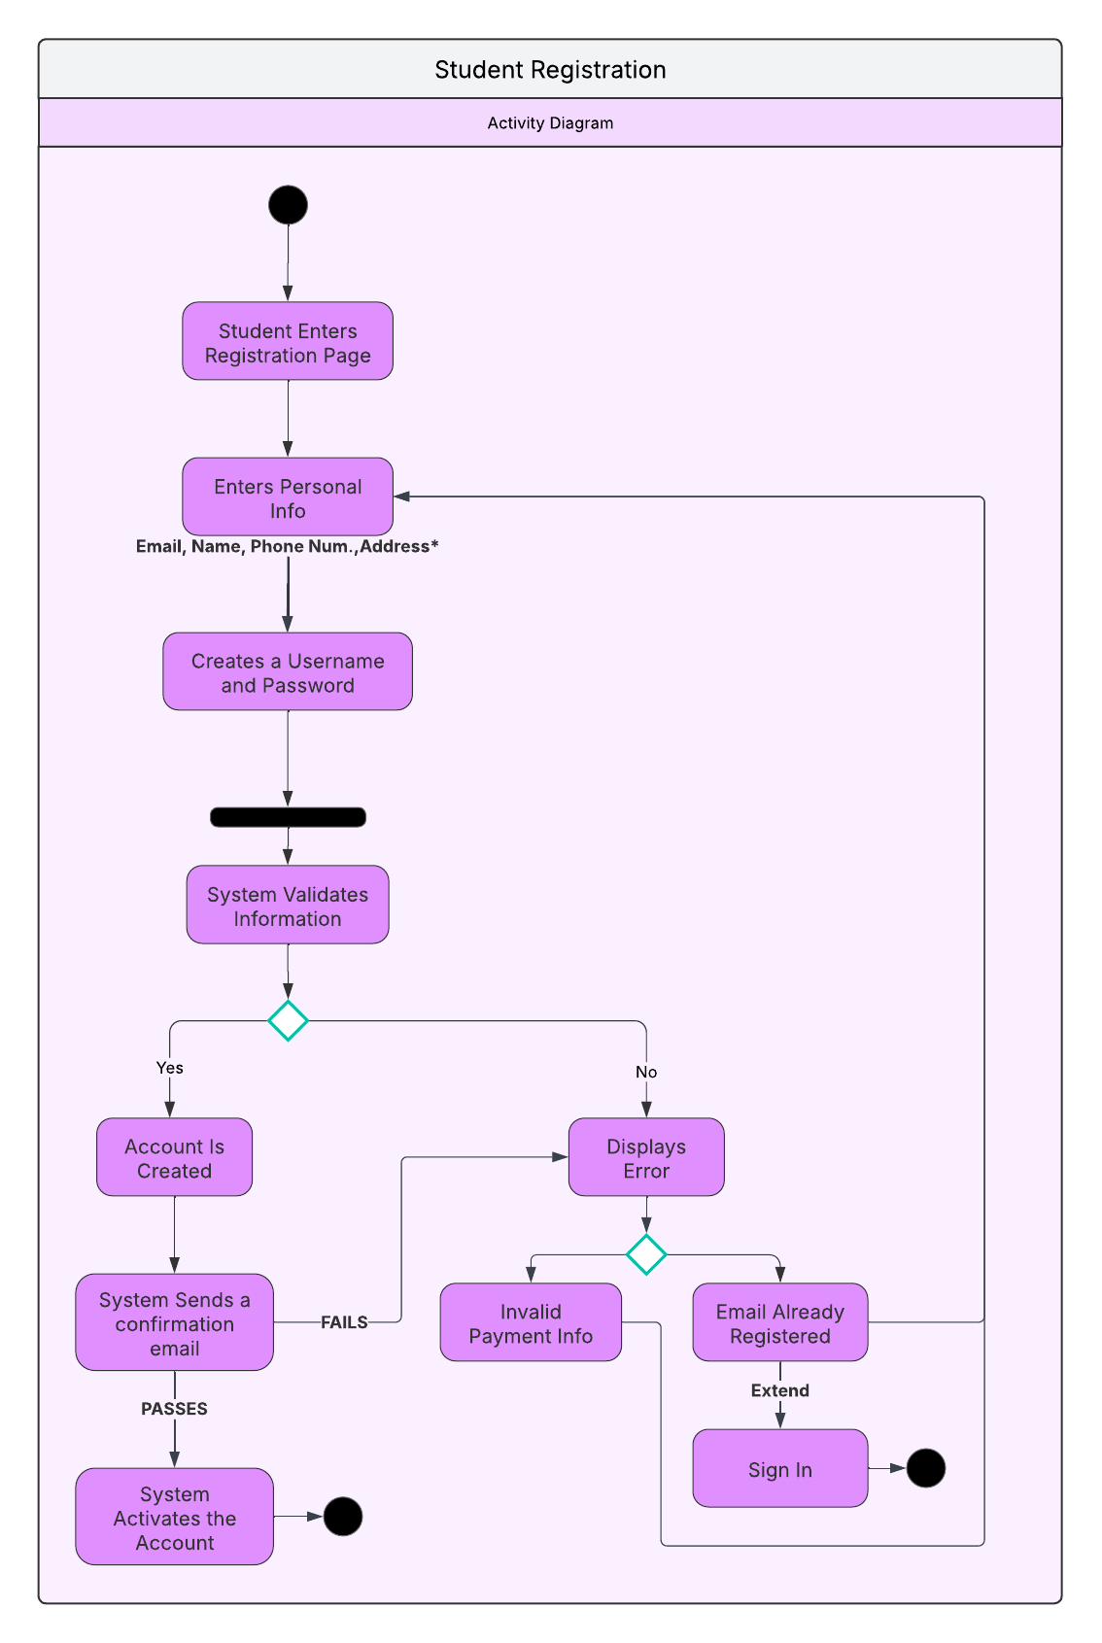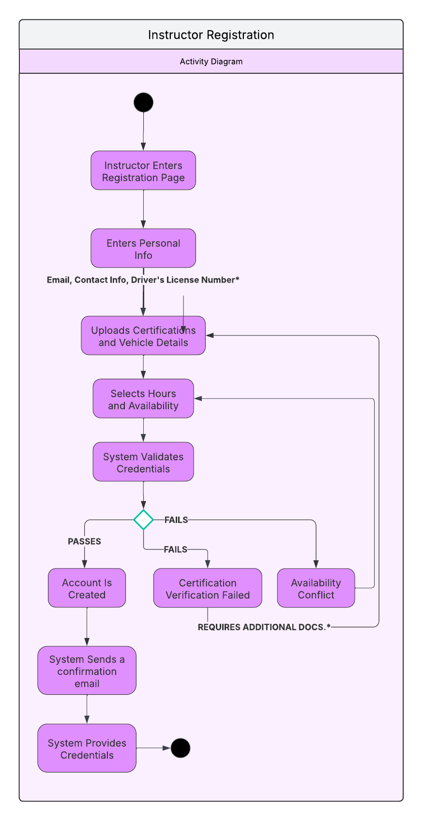

### UML Sequence Diagram

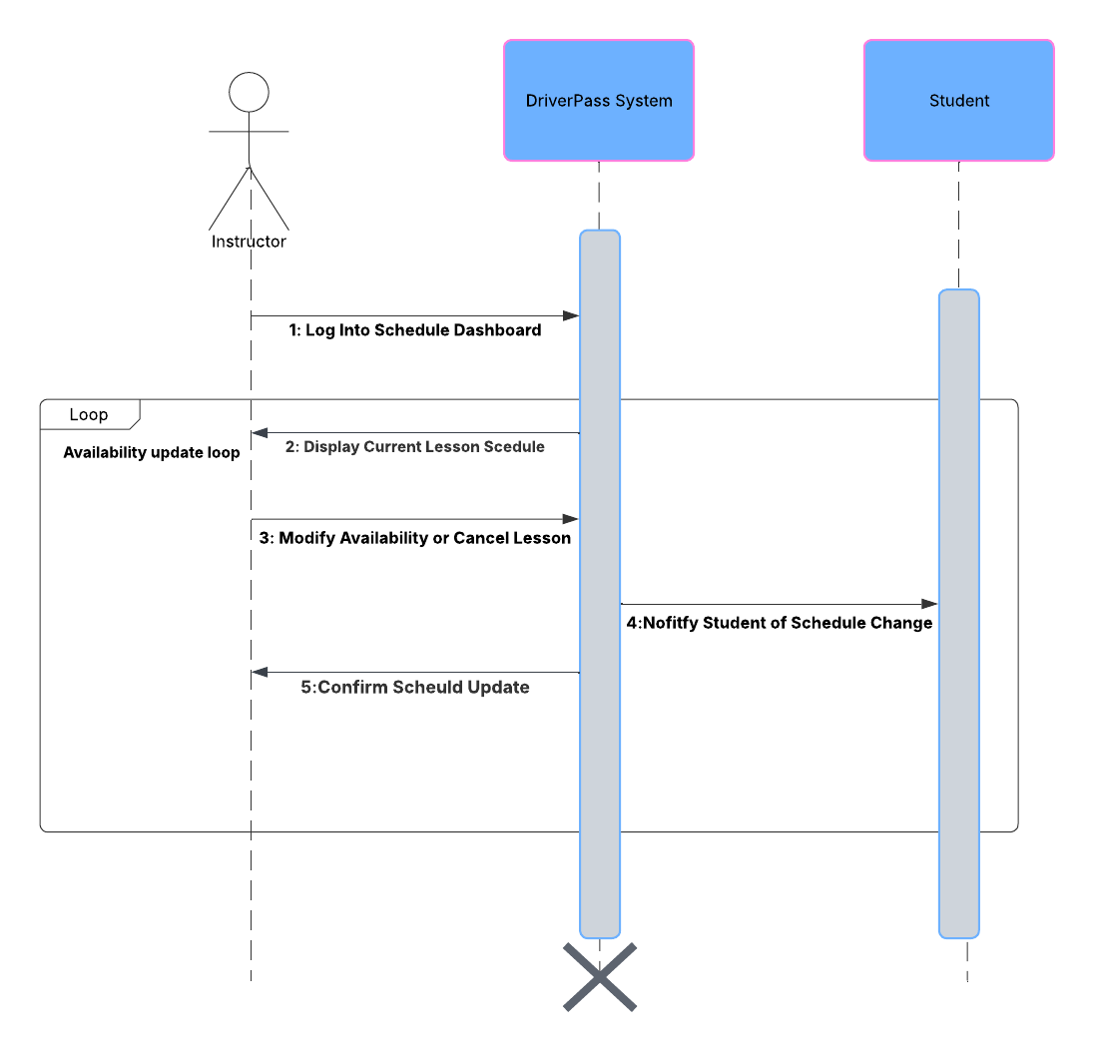

UML Class Diagram

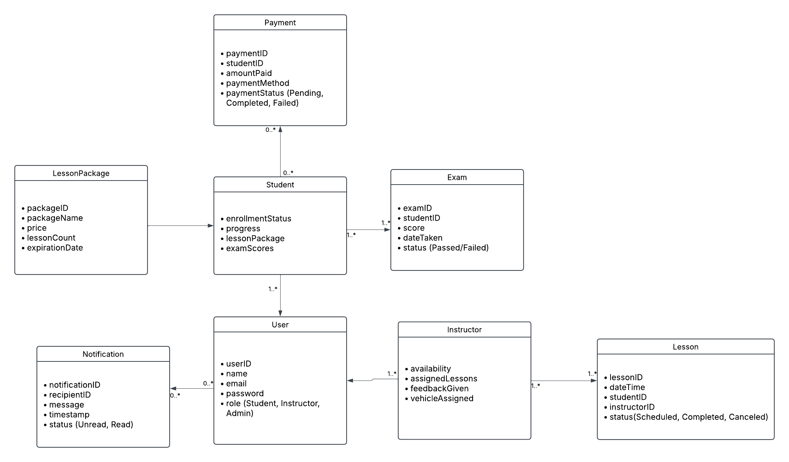

## Technical Requirements

The **DriverPass system** will run on a computer server and use a database to store user and lesson information. The website will be built with **HTML, CSS, and JavaScript**, while the system's functions will be managed using **Python (Django) or PHP (Laravel)**. To keep user data safe, it will have **password protection and encryption**. Tools like **Lucidchart** will help with planning, and **GitHub** will be used to keep track of changes. The system will be designed to handle a large number of users smoothly.